Student e-portfolio

Identification
https://open.gpmu.org/
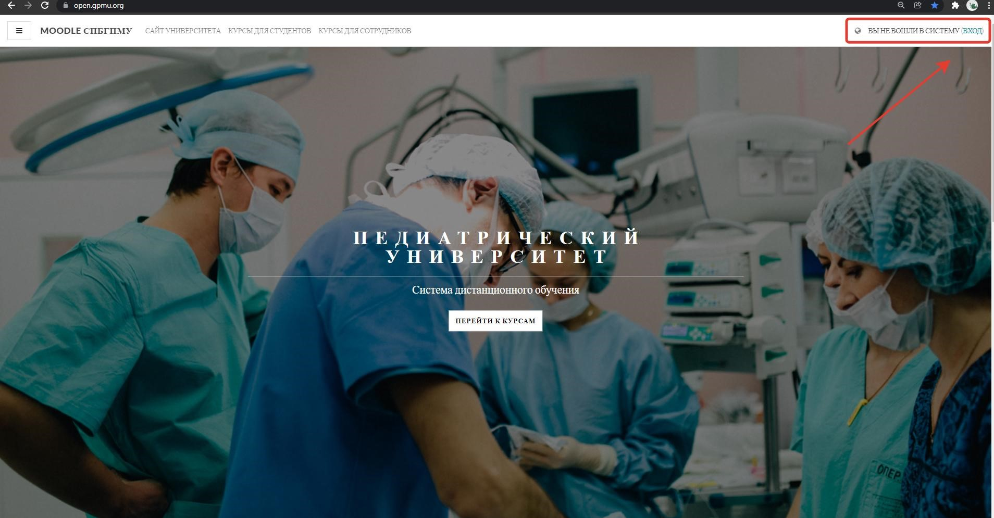

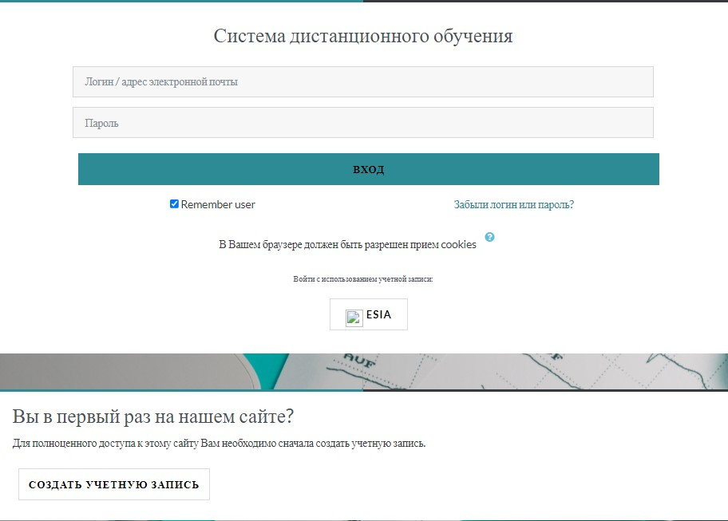

If you don’t have a login and password, then you need to register (the "Создать учетную запись" button).

Creation of an electronic portfolio
You must click the "Перейти к курсам" button, then go to "Курсы для студентов", on the right is the "Электронное портфолио" block. In this block, you must select the item "Мое портфолио".
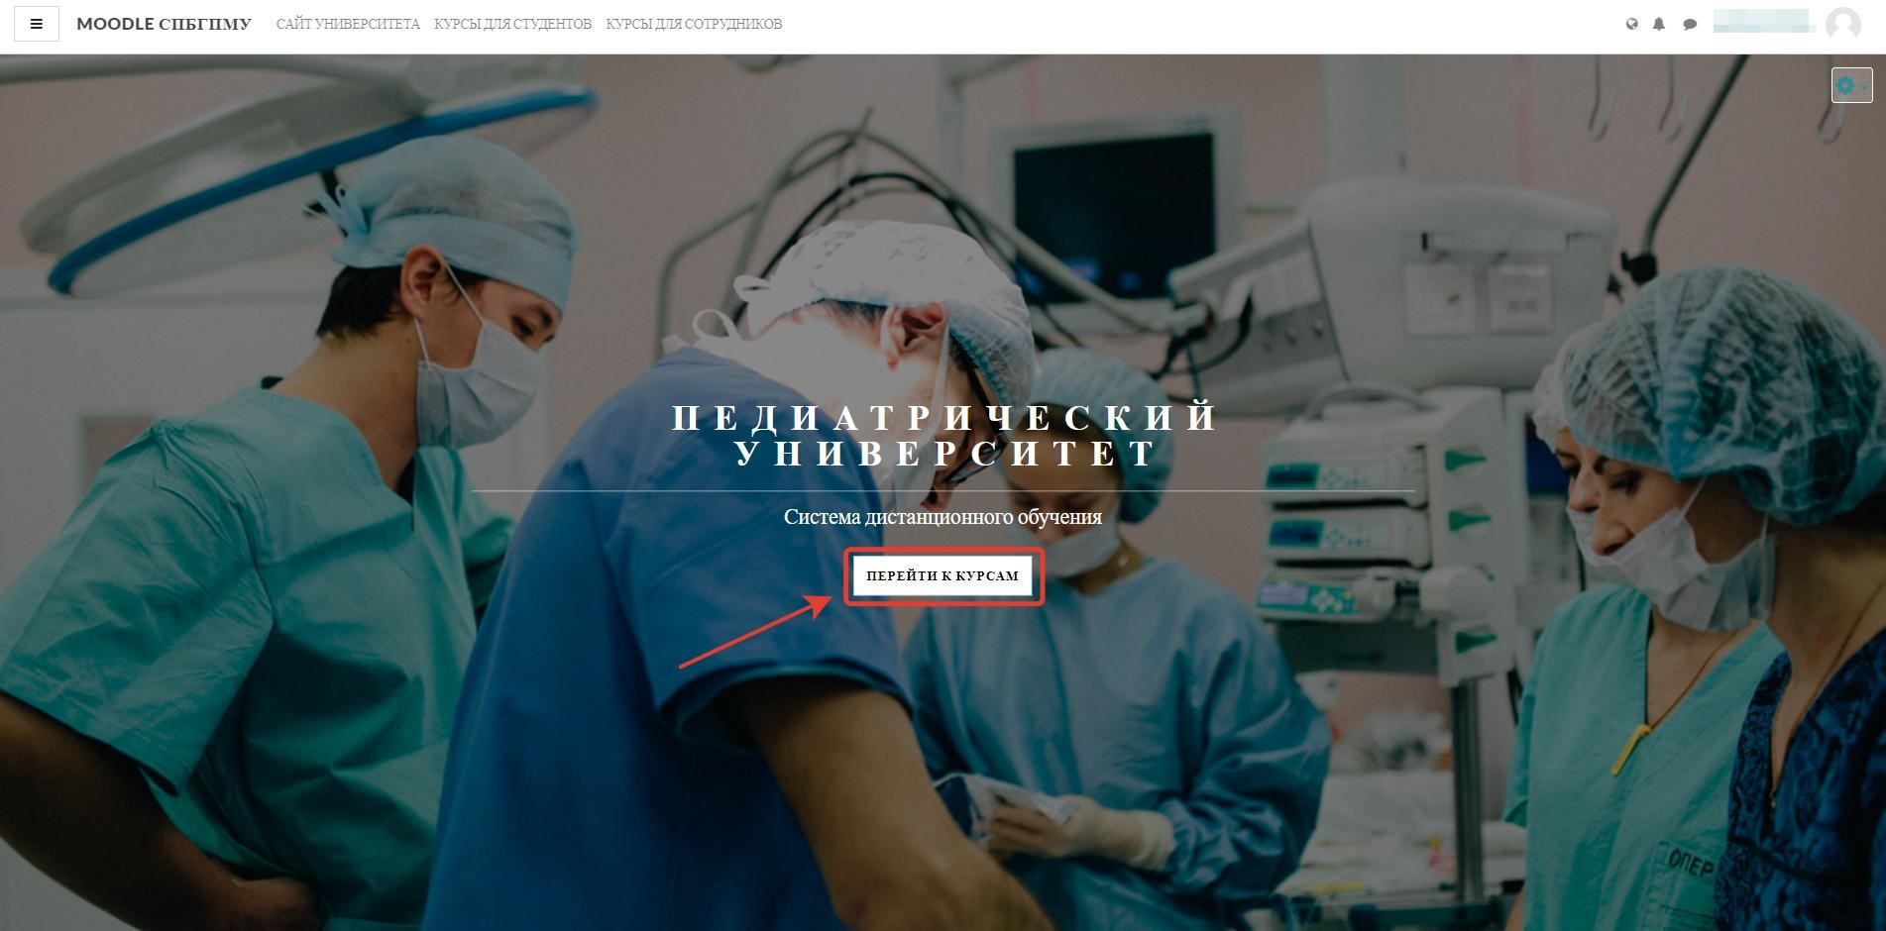

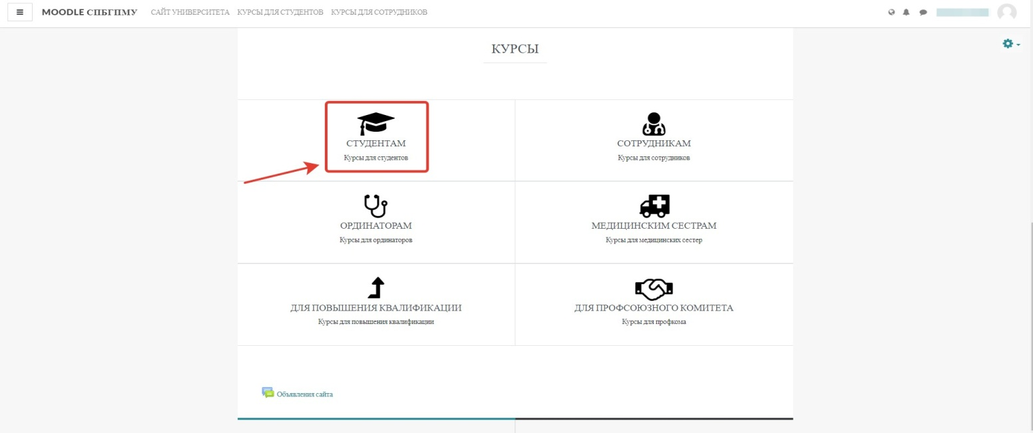
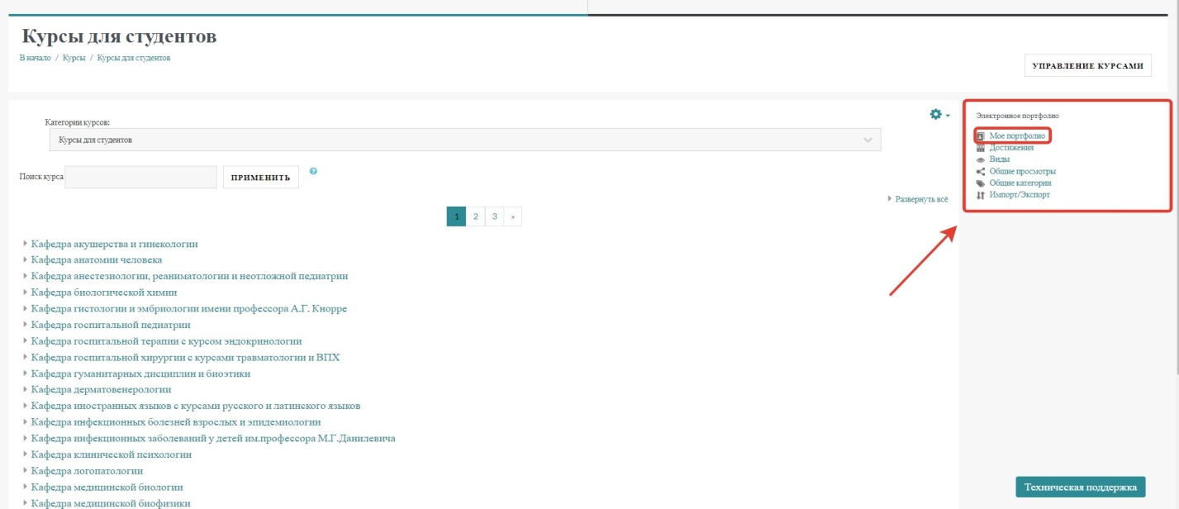

Select «Редактировать».

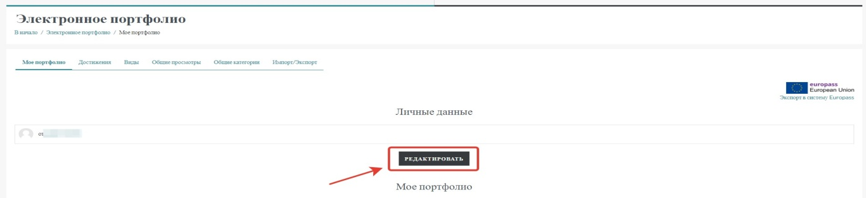

On the editing page, fill in the data according to the proposed sample (copy the text from the instructions after the picture and change it to your data):

PORTFOLIO
SIDOROV IVAN IVANOVICH, STUDENT OF PEDIATRIC UNIVERSITY
Year of admission: 2019
Direction of study: 27.03.02. Quality control. (undergraduate)
Full-time education
Group: 2345A
Contact information: dar@mail.ru, +7(919)234-54-34

Next click the button «Сохранить».

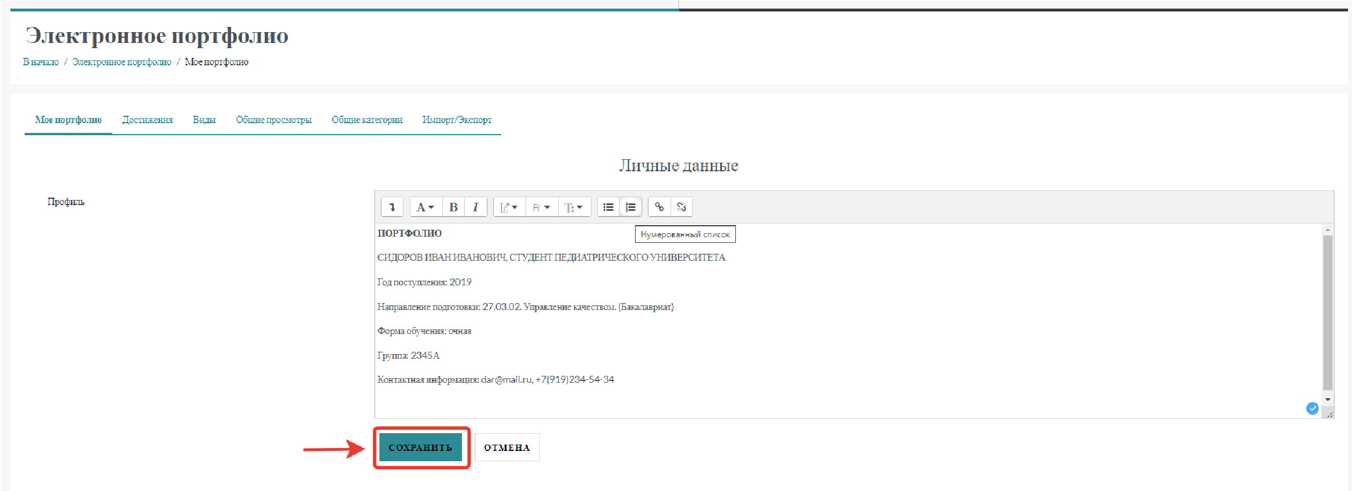

Go to the " Достижения " tab. Click « Категория»icon to create a document folder.

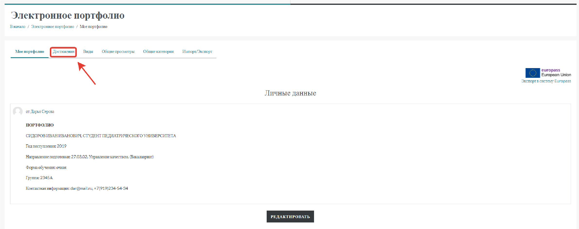
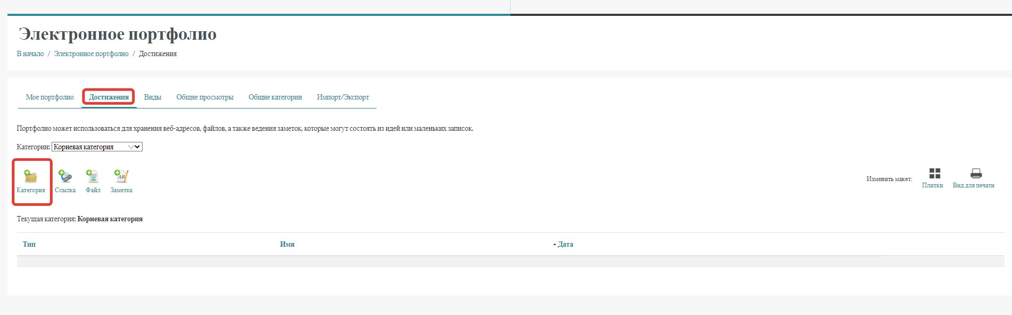

Enter the name of the folder - Portfolio in the "Название" field. Click «Сохранить» button.

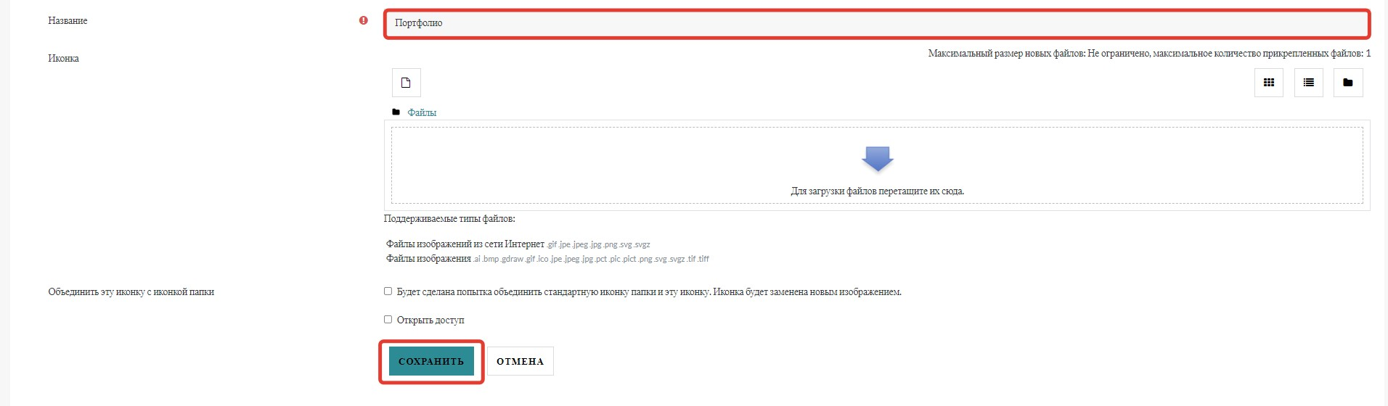

Clicking on the name "Portfolio" - open this folder and click on the "Категория" icon again. Now create a folder called "Scientific activity", save. It will turn out as in the following figure.

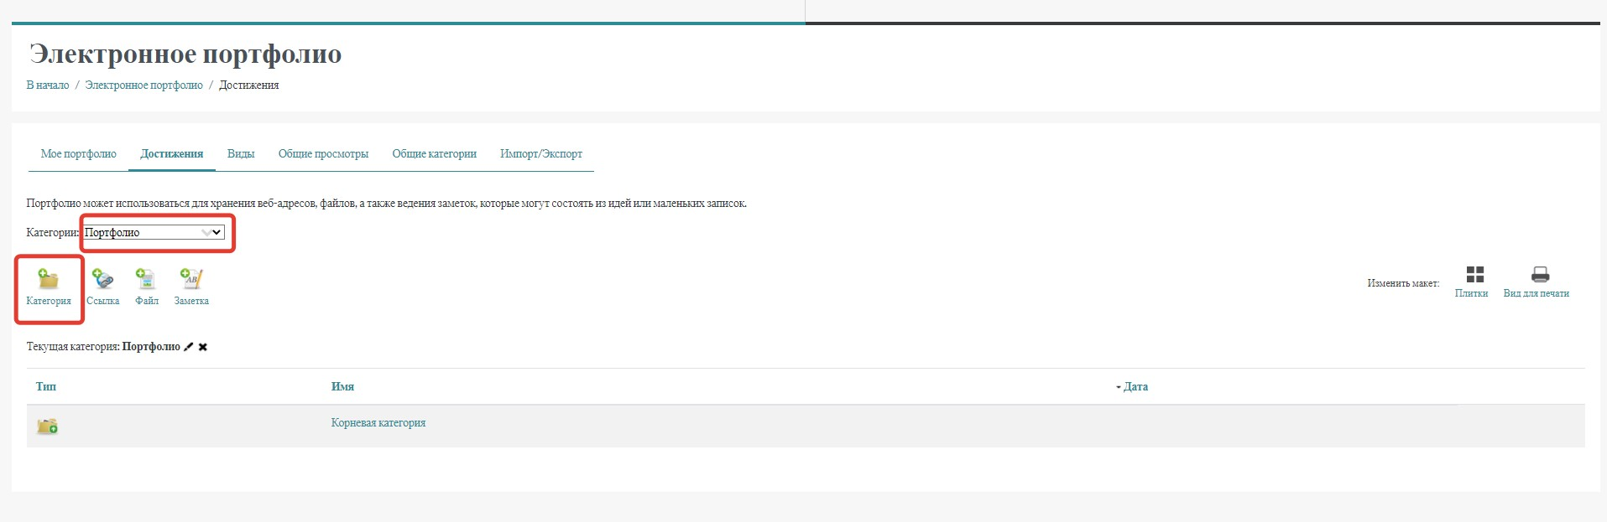
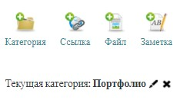

Comment. The "pencil" icon edits an element, and the "cross" icon deletes that element.

Using the “Категория” icon, create four more folders under the Portfolio category: Academic Activities, Sports Activities, Cultural Activities, and Community Activities.

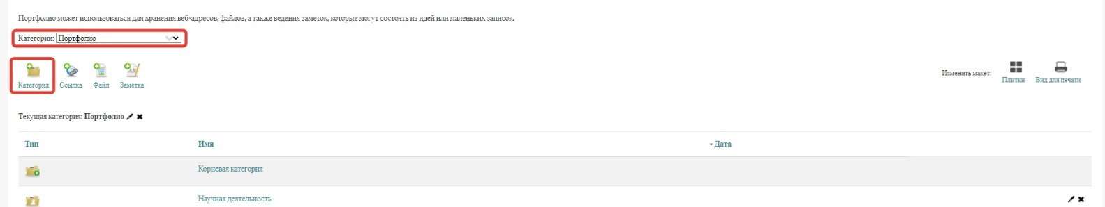

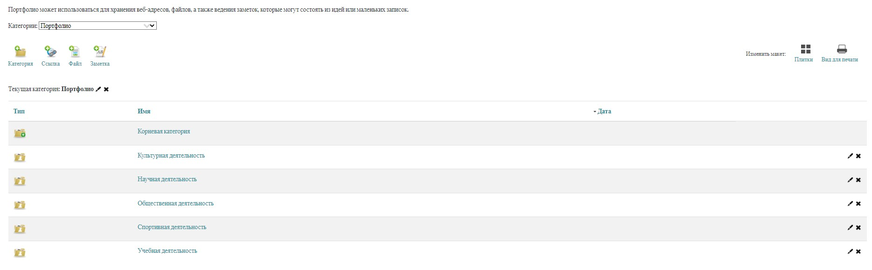

Consider adding a specific resource to the appropriate folder. You can use file icons, links, or just notes to add a resource.
Try adding a file:
1. Click the "Файл" icon to add. Complete the Add File page:
• enter the name of your resource;
• select the folder where this file will be located;
• You can also provide a link to the file, but this field is optional;
Next, attach the file by clicking on the "Добавить" icon. A file selection window will open, click the "Выбрать файл" button, specify the location of the file, click the "Загрузить этот файл" button. You can upload files in docx, pdf, rtf, etc. formats as long as the file size limit is 8 MB.

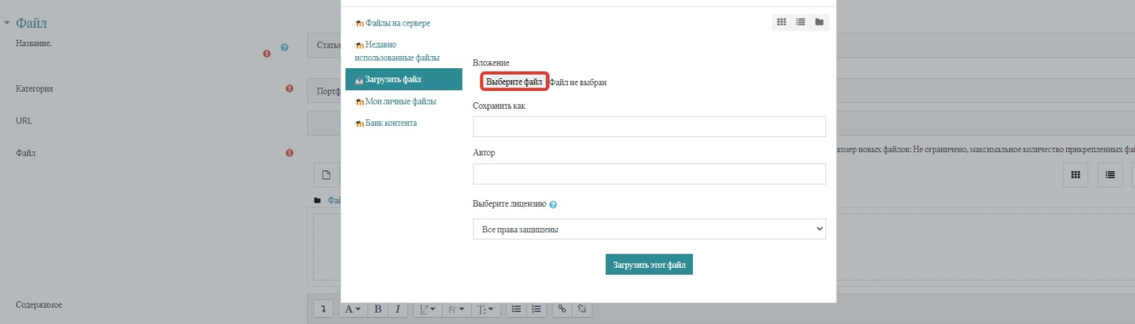
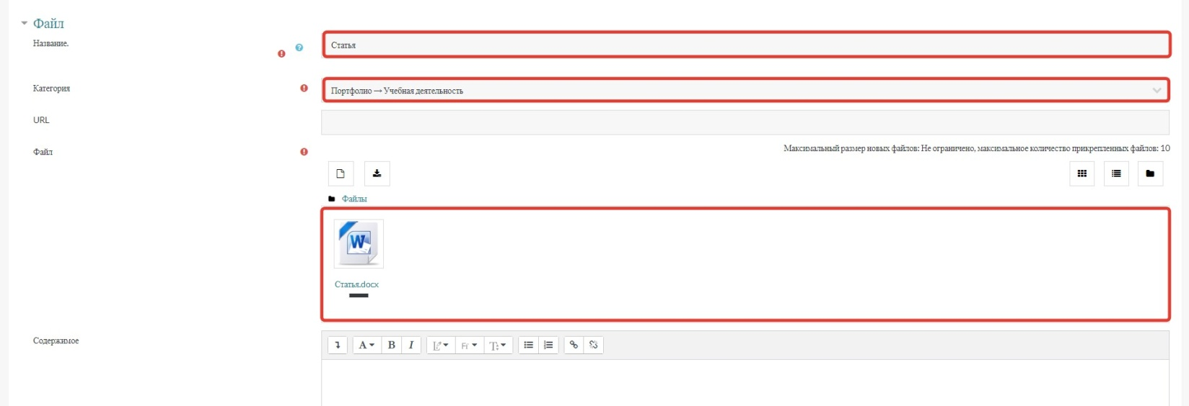

The "Содержимое" field can be filled in if you want to give any explanation about the file. Click the "Сохранить" button.

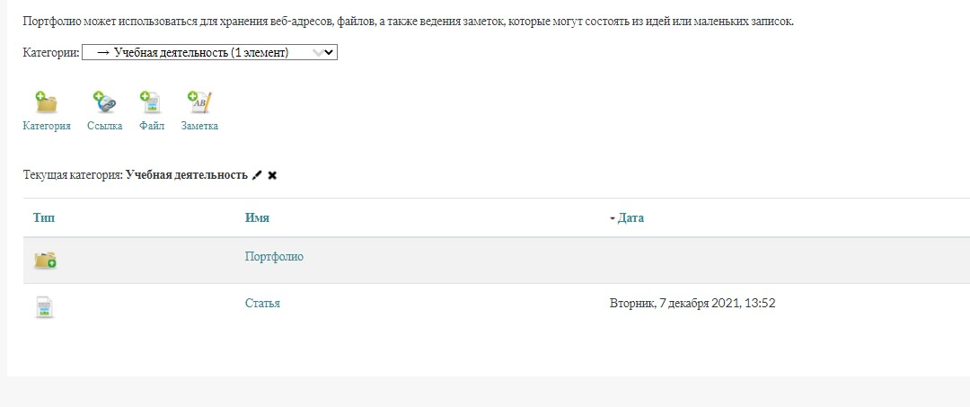

Links. If there is a link to your achievement, then it is better to add a link to the file: Click the Link icon. 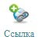:
• enter the name of your resource;
• select the folder where the link will be located;
• insert a link to your achievement.

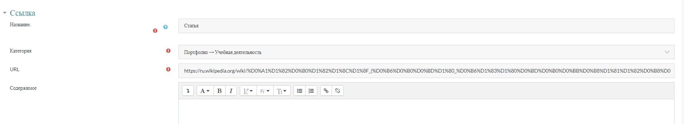
Click the "Save" button.

Availability of materials for viewing

- Go to the "Виды" tab. Click the “Добавить вид” button.

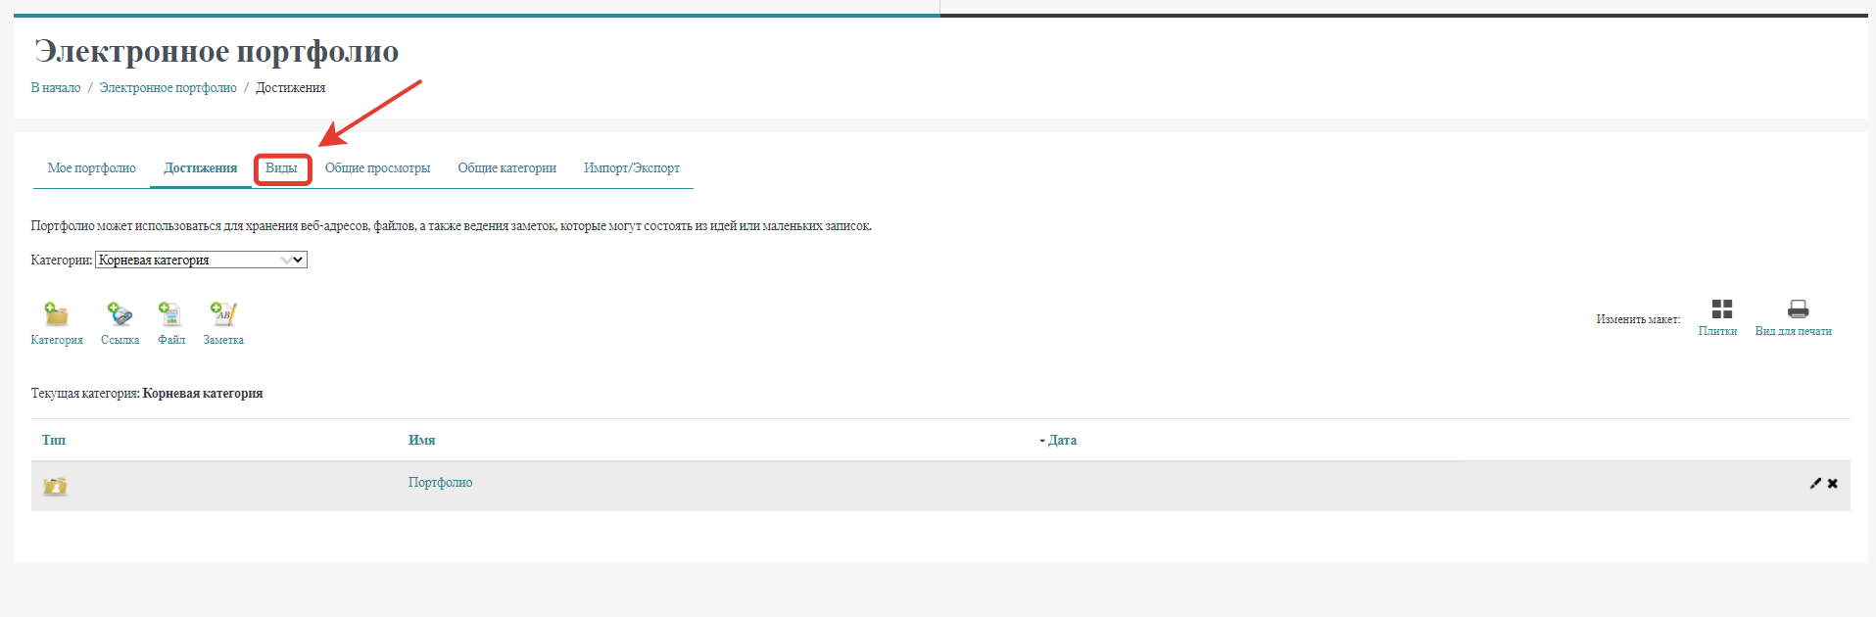

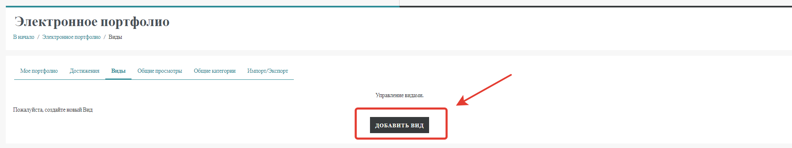

2. Give a name - My Portfolio, click the "Сохранить" button.
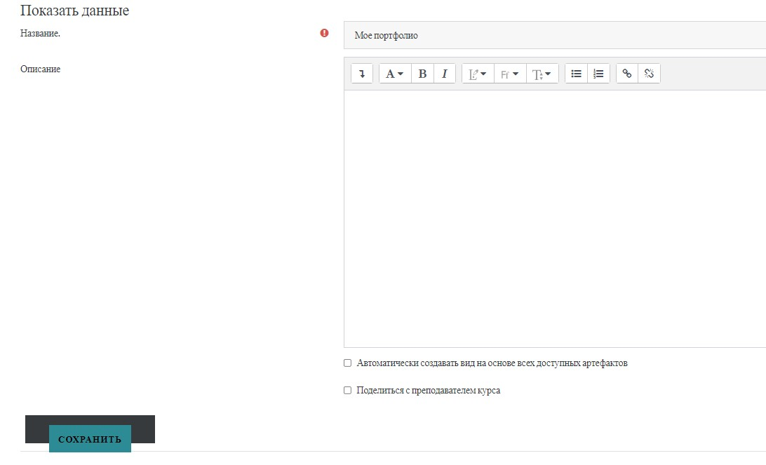

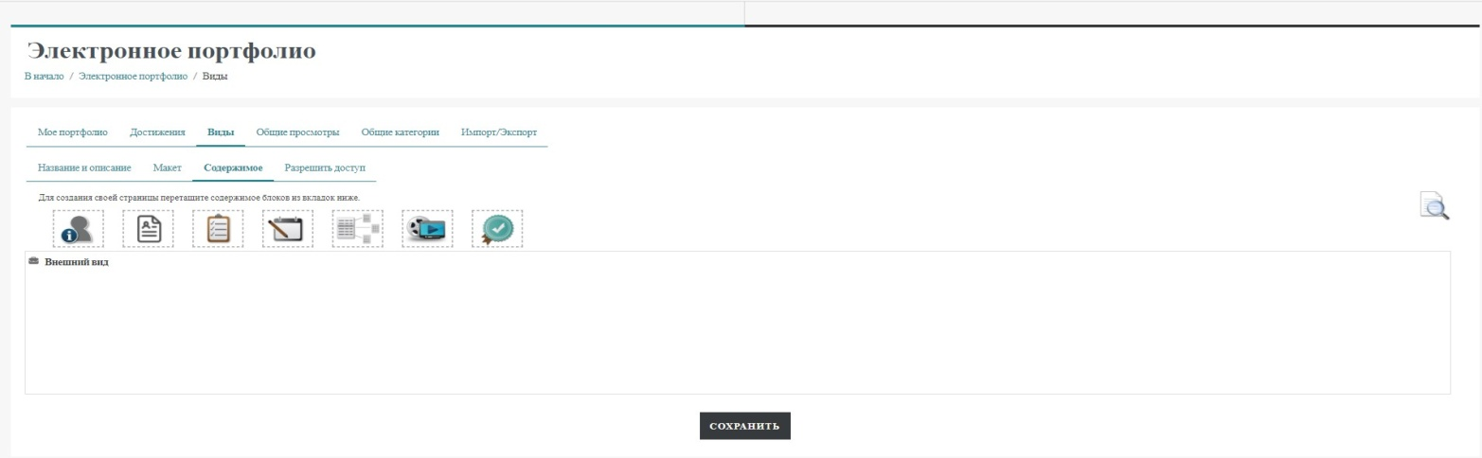

3. Icon «Персональная информация»  drag to the area «Внешний вид». Fill the block window according to the picture. Click «Добавить». Click «Сохранить».

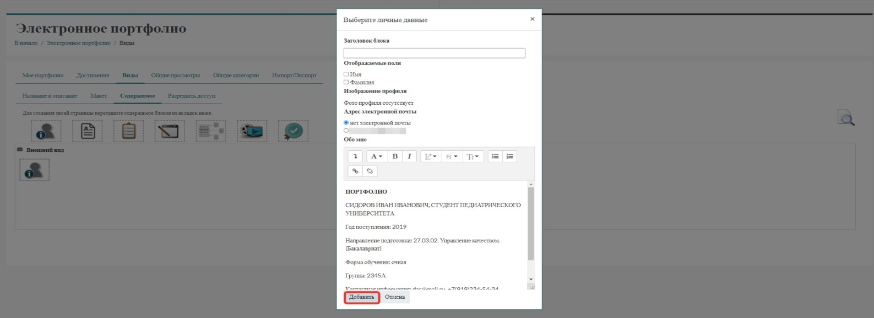
4. Icon «Элементы» 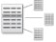 drag to the area «Внешний вид». Fill the block window according to the picture. Click «Добавить». Click «Сохранить».

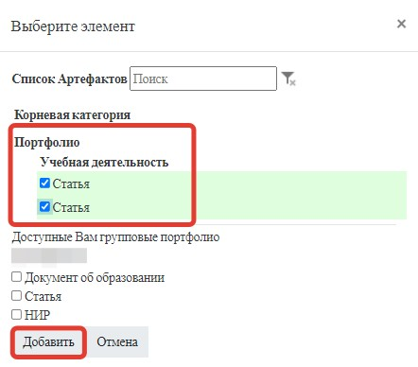

5. Click the «Разрешить доступ» tab. Check the "Внутренний доступ" box. In the "Найти" field, enter «Деканат по работе с иностранными обучающимися (The dean’s office for Foreign students) » and click the "Find" button.

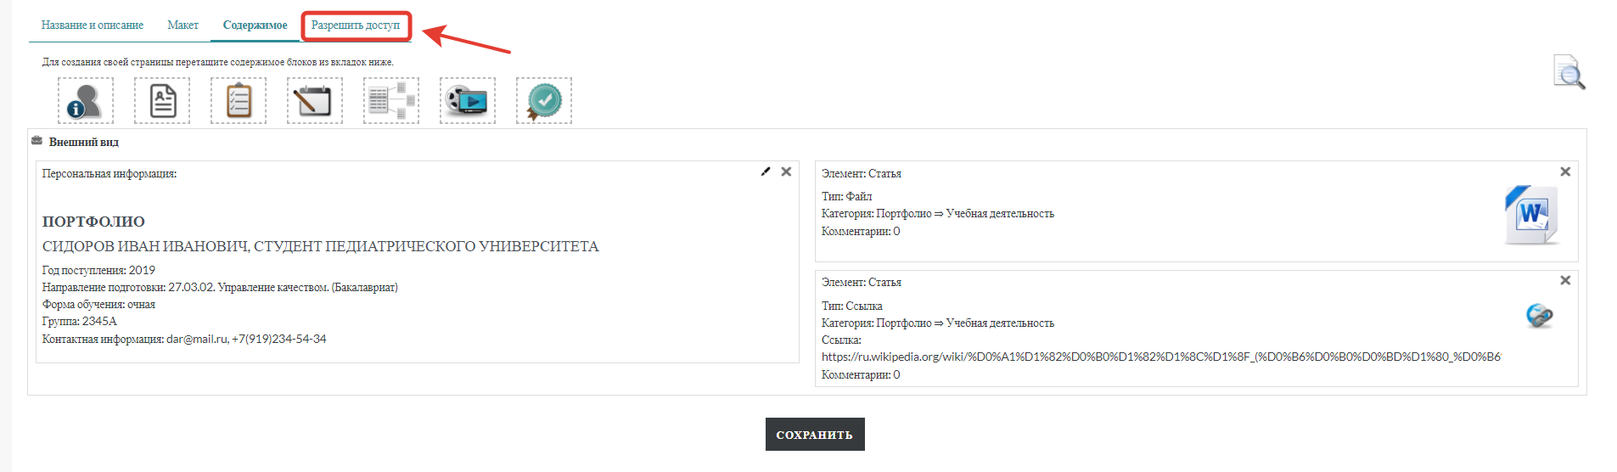
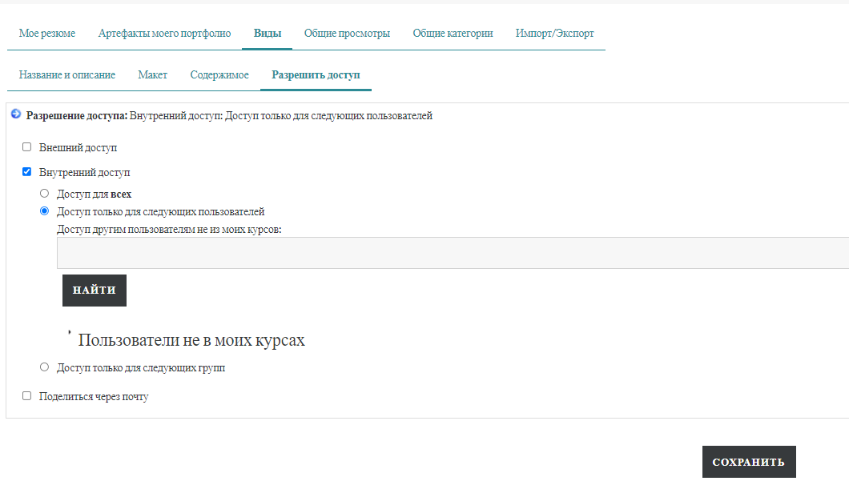
- Check the box next to Деканат по работе с иностранными обучающимися (The dean’s office for Foreign students), click «Сохранить» button.
- In the same way you need to add Центр Цифровых Технологий (ЦИОТ) and then click the «Назад» button.
If you want everyone to see your portfolio, then select «Доступ для всех», in this case, you do not need to add a dean's office and a ЦИОТ.

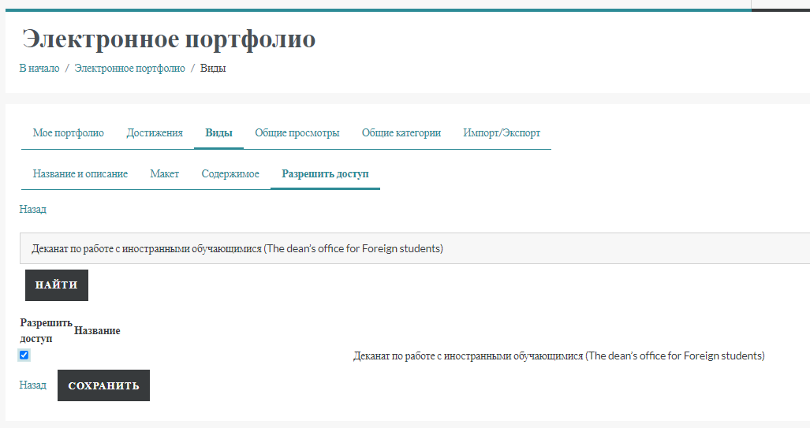

- On «Виды» tab, make sure your dean's office and Центр цифровых технологий (ЦИОТ) is granted access next to your portfolio in the access settings.

